**For the given JSON iterate over all for loops (for, for in, for of, forEach)**

//https://gist.github.com/lavishjain36/5aa2790d945c6ccf9abbd2c29085cfb6

**var obj = [**

**{ person: "Name 1", age: "2", company: "GUVI" },**

**{ person: "Name 2", age: "5", company: "GUVI geek" },**

**{ person: "Name 3", age: "8", company: "GUVI geek network" },**

**];**

**//for loop**

**Code:**

for (let i = 0; i < obj.length; i++) {

    if(obj.hasOwnProperty(i))

    {

    console.log(obj[i]);

    }

  }

**Output**:

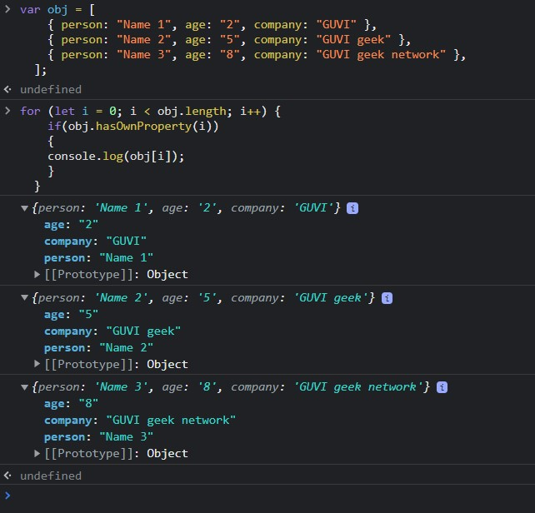

**//for each loop (function oriented)**

**Code:**

obj.forEach(element => {

    console.log(element);

});

**Output:**

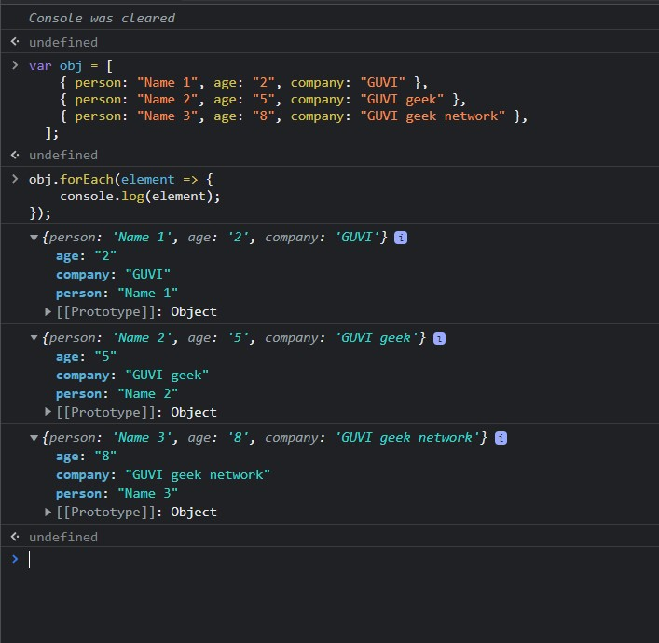

**//for in loop (won’t follow order)**

**Code:**

for (let i in obj)

{

    console.log(i)

    if(obj.hasOwnProperty(i))

    {

    console.log(obj[i])

    }

}

**Output:**

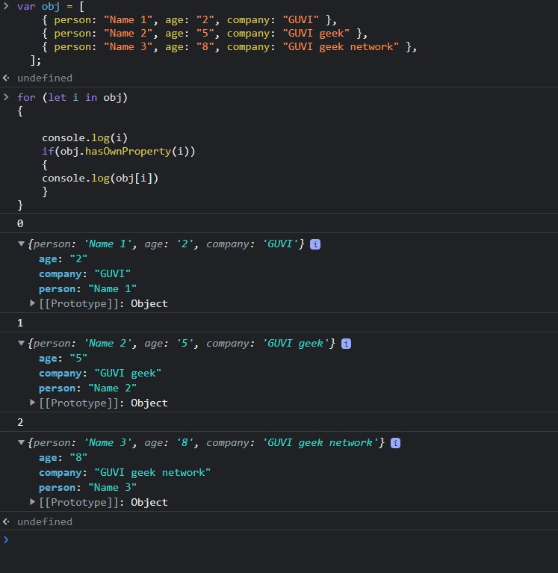

**//for of**

**Code:**

for (let x of obj) {

    console.log(x)

}

**Output:**

